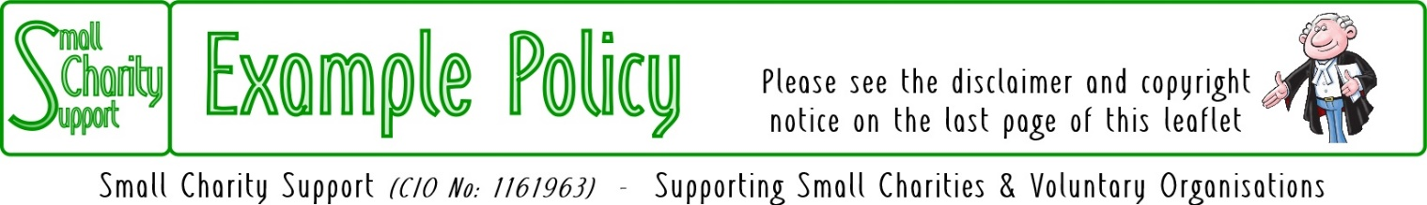
Last updated: 12-Apr-21

Safeguarding Vulnerable Adults Policy

Safeguarding is everyone’s responsibility:
Safeguarding vulnerable adults is a part of the wider role of safeguarding and promoting welfare. This refers to the activity which is undertaken to protect specific vulnerable adults who are suffering or are at risk of suffering significant harm. As adults and/or professionals or volunteers, everyone has a responsibility to safeguard vulnerable adults and promote their welfare.
Safeguarding and promoting the welfare of vulnerable adults – and in particular protecting them from significant harm - depends upon effective joint working between agencies and professionals that have different roles and expertise.
Some of the most vulnerable adults and those at greatest risk of social exclusion, will need co-ordinated help from health, education, social care, and quite possibly the voluntary sector and other agencies, including justice services.
For those vulnerable adults who are suffering, or at risk of suffering significant harm, joint working is essential, to safeguard and promote their welfare and – where necessary – to help bring to justice the perpetrators of crimes against them. All agencies and professionals should:
- be alert to potential indicators of abuse or neglect;
- be alert to the risks which individual abusers, or potential abusers, may pose to vulnerable adults;
- share and help to analyse information so that an assessment can be made of the individual's needs and circumstances;
- contribute to whatever actions are needed to safeguard and promote the individual's welfare;
- take part in regularly reviewing the outcomes for the individual against specific plans; and
- work co-operatively with parents and/or other carers unless this is inconsistent with ensuring the individual's safety.
As one of its major activities the charity seeks to serve the needs of vulnerable adults, promoting holistic development.
In doing so the charity takes seriously the welfare of all vulnerable adults who come onto its premises or who are involved in its activities.
The charity aims to ensure that they are welcomed into a safe, caring environment with a happy and friendly atmosphere.
The charity recognises that it is the responsibility of each one of its staff, paid and unpaid, to prevent the neglect, physical, sexual or emotional abuse of vulnerable adults and to report any abuse discovered or suspected.
The charity recognises its responsibility to implement, maintain and regularly review procedures, which are designed to prevent and to be alert to such abuse.
The charity is committed to supporting, resourcing and training those who work with vulnerable adults and to providing supervision.
The charity is committed to maintaining good links with the statutory social services authorities.

Procedures
For reasons of consistency and practicality, the charity's procedures for safeguarding vulnerable adults will be the same as those for safeguarding children and young people (qv) except where the law, or the specific circumstances of an individual's need require otherwise.

Change Record
Date of Change: | Changed By: | Comments:
dd/mm/yy | XX | Policy approved by the Trustees

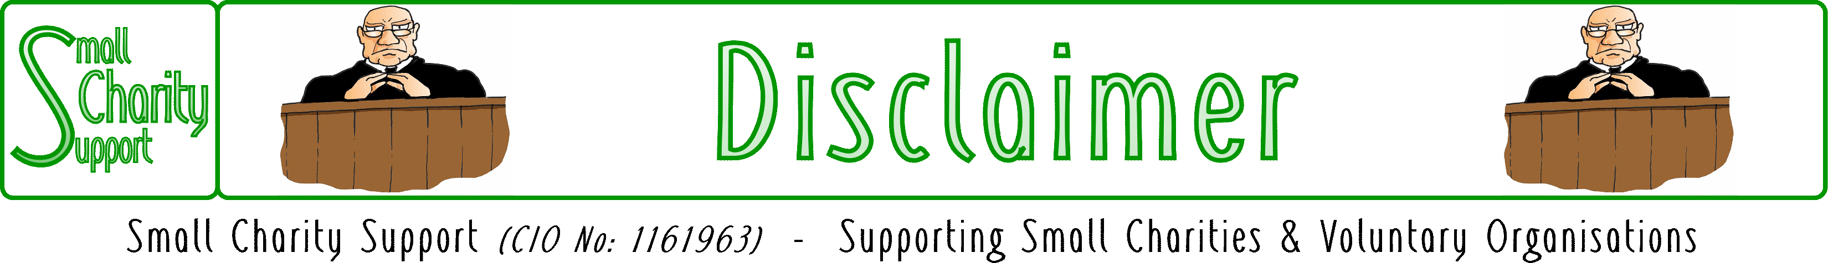

While it is Small Charity Support’s intention to provide you
with the best possible support and information as we are able,
it is important that you read and give due consideration
to the following notices.

The information contained in this leaflet is provided in summary form and is made available for general information purposes only. It has not been prepared with your specific needs in mind and is not advice of any kind (whether legal, financial, or otherwise).
Please take the time to check the information in this leaflet is suited to your specific circumstances and if you are making any important decisions, such as on financial, legal or tax matters, you should consult a qualified professional adviser who can provide specific advice based on your position.
Small Charity Support does not assume any liability or responsibility to any person or entity for the information contained in this leaflet and you should not rely on any information contained in this leaflet. Small Charity Support makes no representation as to, and does not assume any responsibility for, the accuracy, completeness or relevance of the information contained in this leaflet.
Please make sure that any sites you link to from this leaflet (or on our website) are appropriate to you, as we do not endorse such websites and have no control over their contents or how (or if) that site operates. Any links or references in this leaflet to a company, entity, service or product does not, in any way, imply an endorsement.

© 2021 Small Charity Support
This leaflet is made available to charities and not-for-profit organisations under a
Creative Commons Attributable – Non Commercial – Share Alike International 4.0 License
That license lets you remix, adapt, and build upon this material non-commercially, as long as you credit Small Charity Support and license your new creations under the identical terms.

